Data Analyst: CGSS, Curriculum Development Support Team- Analytics

Completed: February 27, 2024

This document provides a detailed analysis of various assessments undertaken during the MOD 2 phase of the Advanced Operation Course. The analysis spans different dimensions of student performance, including the distribution of weighted total scores, division movement plans, online exam results, and the contribution to group learning (CTGL). Through a series of visualizations—histograms, scatter plots, boxplots, violin plots, heatmaps, facet grids, and pair plots—we examine central tendencies, spread, skewness, outliers, and correlations among different metrics. This multifaceted approach allows us to draw comprehensive insights into student performance, instructional effectiveness, and assessment design.

## Key Findings and Insights

Learner Performances Metrics:

|  |  |  |  |  |  |  |
| --- | --- | --- | --- | --- | --- | --- |
|  | Wt_TTL | CTGL | Div_mvmnt_plan | BB_exam_us | BB_exam_ims | BB_Combined_Scores |
| mean | 93.88 | 94.88 | 94.93 | 92.47 | 90.87 | 92.37 |
| min | 80.8 | 85 | 80 | 64 | 0 | 52 |
| max | 99.7 | 100 | 100 | 100 | 100 | 100 |
|  |  |  |  |  |  |  |

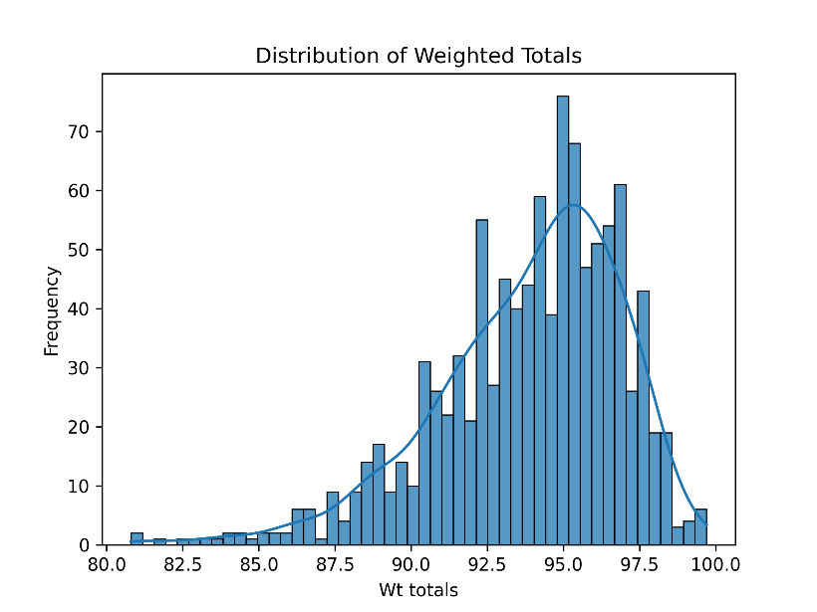

The comprehensive analysis of each assessment begins on page 5.

## Weighted Total Scores and Division Movement Plans

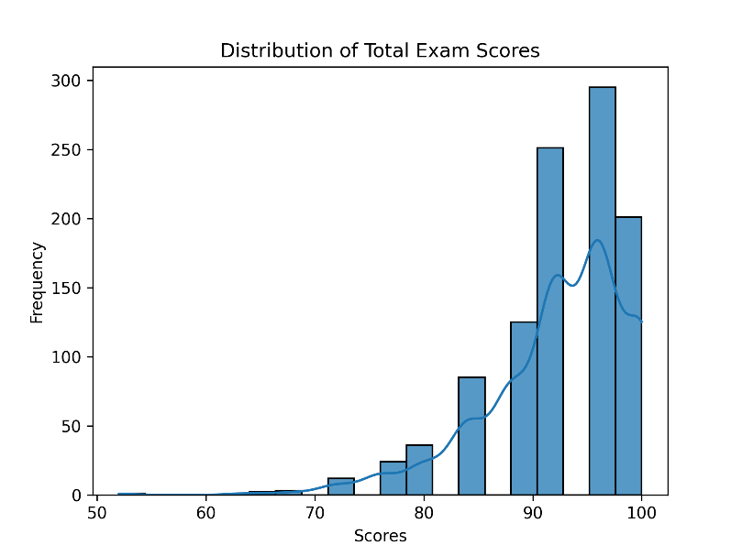The analysis of weighted total scores and division movement plans revealed a high concentration of scores in the A range, suggesting consistent performance among students and potentially effective teaching methodologies. However, the presence of a bimodal distribution in the division movement plans points to varying levels of understanding or application among students, warranting a review of instructional methods or materials.

### **Online Exam Results**

The examination of online exam results, particularly comparing U.S. students with International Military Students (IMS), highlighted differences in preparation levels or prior knowledge, with IMS students achieving higher scores. This discrepancy suggests the need for further investigation into study resources and support systems available to each group.

### **Contribution to Group Learning (CTGL)**

The CTGL scores analysis underscored the importance of a standardized rubric for assessing participation grades, aiming for equity in assessment and providing detailed, actionable feedback to students. The correlation between CTGL and weighted total scores across different teams highlighted varying performances, suggesting room for curriculum adjustments and further support for lower-performing students.

### **Calendar Description automatically generatedVisualizations and Correlation Analyses**

Through various visualizations, including boxplots, violin plots, and facet grids, we observed the distribution of CTGL scores across teams, identifying patterns of performance, variability, and outliers. The correlation heatmap provided insights into the relationships between different assessment metrics, revealing redundancies and the need for assessment diversification.

## Conclusion and Recommendations

The thorough analysis of the MOD 2 phase assessments has illuminated areas of strength in the Advanced Operation Course, such as high overall performance and effective teaching strategies, as well as areas needing attention, like the need for assessment review and additional student support. To further enhance the learning experience and assessment strategies, the following recommendations are proposed:

Instructional and Assessment Review: Refine instructional materials and assessment criteria to address observed bimodal distributions and ensure clarity and accessibility for all students.

Standardized Rubrics: Implement standardized rubrics for subjective assessments like CTGL to ensure fairness and provide clear expectations and feedback.

Curriculum Adjustments: Adjust the curriculum to provide a range of challenges that can distinguish between varying levels of student mastery, particularly for assessments showing high concentrations of scores within a narrow range.

Support for Lower-Performing Students: Identify common challenges and provide targeted support to students scoring at the lower end of the distribution.

Further Investigation into Exam Preparation: Investigate differences in exam preparation and support systems between U.S. and IMS students to address disparities in performance.

Feedback Mechanisms: Establish feedback mechanisms for students to share their experiences and perceptions of exams and assignments, facilitating continuous improvement of teaching and assessment practices.

This comprehensive analysis not only sheds light on the current state of student performance and assessment efficacy within the Advanced Operation Course but also sets the foundation for ongoing improvements in curriculum design, teaching strategies, and student support mechanisms.

# M200 Comprehensive Analysis Report

Analyst: Mr. Jason Ballard, Command and General Staff School

Date 27 February 2024

## Performance metrics for MOD 2, for the MOD 2 phase of the Advanced Operation Course.

|  |  |  |  |  |  |  |
| --- | --- | --- | --- | --- | --- | --- |
|  | Wt_TTL | CTGL | Div_mvmnt_plan | BB_exam_us | BB_exam_ims | Combined_Scores |
| count | 1035 | 1006 | 1034 | 916 | 120 | 1035 |
| mean | 93.88 | 94.88 | 94.93 | 92.47 | 90.87 | 92.37 |
| std | 3.03 | 2.33 | 2.51 | 6.54 | 11.23 | 6.66 |
| min | 80.8 | 85 | 80 | 64 | 0 | 52 |
| 25% | 92.2 | 93.99 | 94 | 88 | 88 | 88 |
| 50% | 94.4 | 94.99 | 95 | 92 | 92 | 92 |
| 75% | 96 | 96.99 | 96 | 96 | 96 | 96 |
| max | 99.7 | 100 | 100 | 100 | 100 | 100 |
| Missing | 6 | 35 | 7 |  |  | 6 |

## Weighted total scores.

Here's an analysis of the plot:

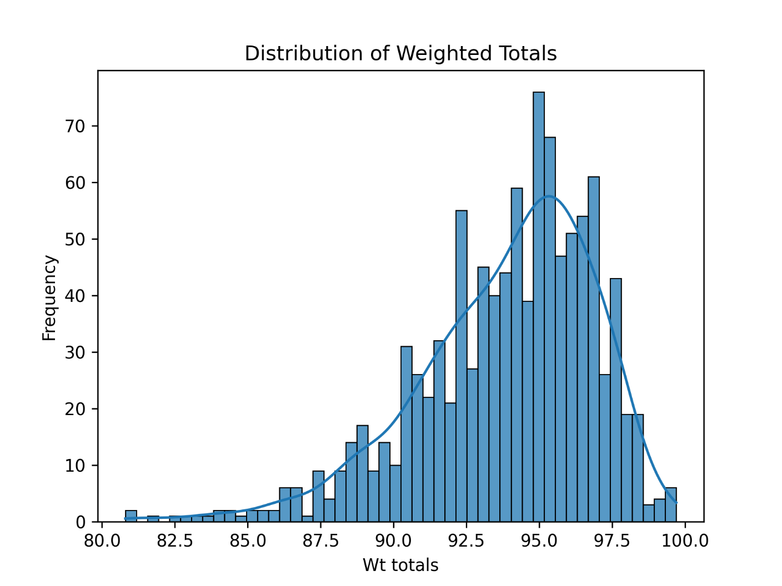Central Tendency: The distribution of weighted totals peaks around 92.5 to 95, indicating that the average score is likely within this range. This central peak suggests that most students are achieving scores in the A range, assuming a typical grading scale.

Spread: The distribution covers a range of scores from 82.5 to 100, with most of the data concentrated around the peak. This narrow spread indicates that the scores are not highly dispersed, and most students have scored within a close range to each other.

Shape: The distribution is symmetrical around its central peak, suggesting a normal-like distribution of scores. This symmetry is a sign of fair assessment across the student population.

Skewness: There does not appear to be a pronounced skew in either direction, although there is a slight tail towards the lower scores, indicating a few students scored lower than the majority.

Outliers: The histogram does not show any significant outliers; all scores seem to fall within an expected range. There are no separate, individual bars distant from the main body of the distribution, which would indicate outliers.

From this analysis, a few insights can be gained:

Consistent Performance: The concentration of scores around the 92.5 to 95 range suggests consistent performance among students, indicating that the course content and assessments are well-calibrated to the students' level of expertise.

Effective Teaching: The lack of a significant number of low scores could imply effective teaching methodologies and/or student preparation for the course.

Assessment Review: The normal-like distribution of scores might suggest that the assessment was fair and appropriately challenging for the cohort. However, if the assessment aims to differentiate more significantly among students, it may need to be reviewed to ensure it is capable of doing so.

Student Support: Students scoring at the lower end of the distribution may require additional support. It might be helpful to investigate if there are common challenges or topics that were more difficult for these students.

Grading Scale Review: If this distribution does not align with expected outcomes, consider reviewing the grading scale or the difficulty of the assessments to ensure they are aligned with the learning objectives of the course.

Curricular Adjustments: If the course intends to have a greater differentiation in performance (i.e., a wider spread of scores), curricular adjustments may be required to provide a range of challenges that can distinguish between varying levels of student mastery.

## Division Movement Plan" submitted by students.

Here’s an analysis of what this tells you and what can be gained from this analysis:

Central Tendency: The distribution has a very sharp peak around the 92.5 score range, indicating that many students received scores around this point. This suggests that the modal score (the most frequently occurring score) is in this region.

Spread: The scores span from just above 80 to 100, but the distribution is not uniform. There are two noticeable peaks (bimodal distribution), one around 92.5 and a less pronounced one around 97.5. This could imply that there are two subgroups within the student population achieving these scores, reflecting different levels of understanding or application of the concepts required for the Division Movement Plan.

Skewness: The distribution shows a slight left (negative) skew, with a tail extending towards the lower scores. However, the peak at 97.5 also suggests a significant number of high-scoring submissions.

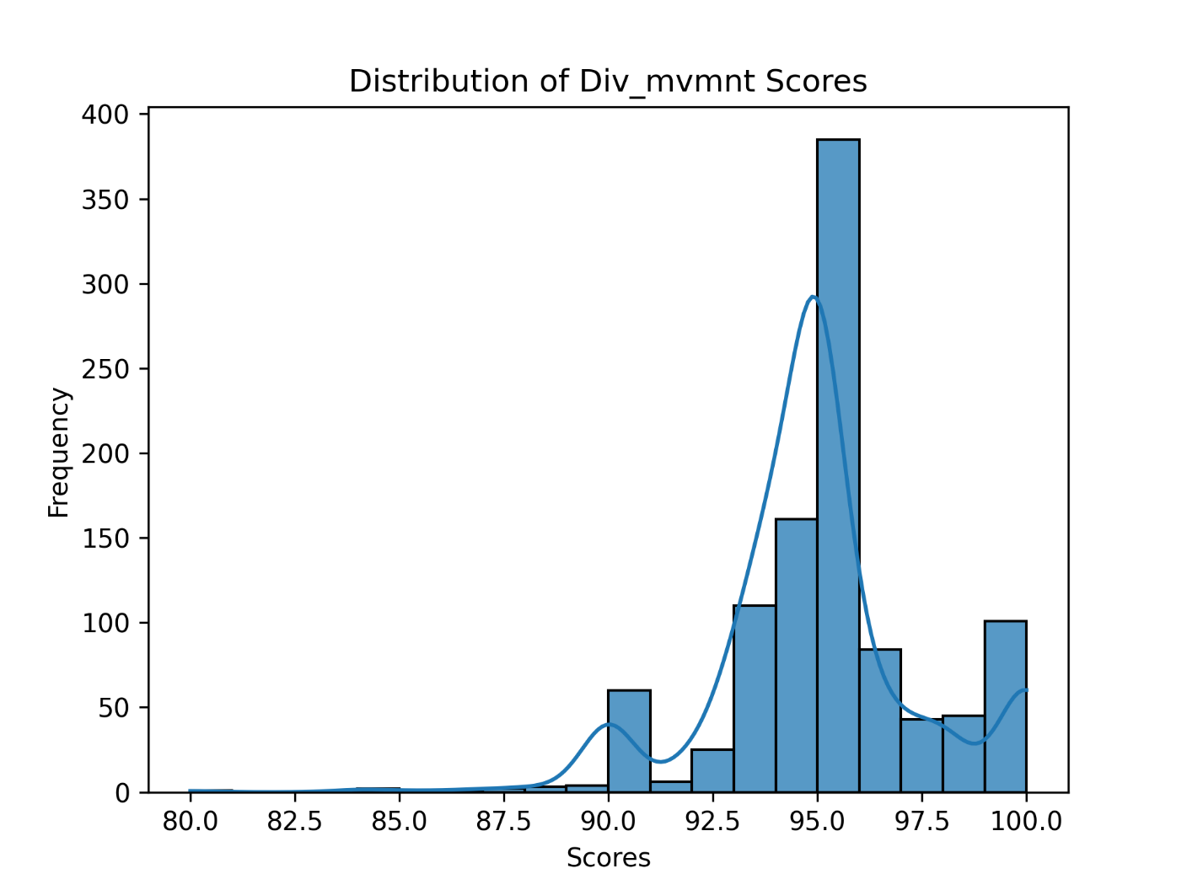

Outliers: The histogram does not show individual data points, so it’s not possible to identify specific outliers from this visual alone. However, the bars at the extremities (low and high ends) suggest that there are students who scored significantly differently than the main group.

### What can be gained from this analysis:

Assessment of Instruction: The concentration of scores around 92.5 may indicate that the instructions or the criteria for the Division Movement Plan were well understood by most students. However, the presence of a secondary peak and a long tail suggests that the instruction or the assessment criteria might not have been equally clear or accessible to all students.

Instructional Review: The presence of a bimodal distribution could warrant a review of the instructional methods or materials provided. It may be beneficial to check if there were any ambiguities or inconsistencies in the way the assignment was presented or explained.

Further Investigation: The bimodal nature of the distribution may be an indication that different groups of students have interpreted the task in different ways, or that there may have been variations in the level of support or resources available to different students.

Targeted Support: Students who have scored in the lower range may benefit from additional support or feedback to understand where they may have missed the mark.

Rubric Refinement: If a standardized rubric was used for scoring, the bimodal distribution could suggest that the rubric may need refinement to ensure it accurately captures the range of student performance and provides clear differentiation between different levels of achievement.

Feedback and Reflection: This distribution provides an opportunity to collect feedback from students about their understanding of the assignment and the challenges they faced. It also allows for reflection on teaching practices and the clarity of the assignment guidelines.

Grade Calibration: If multiple graders were involved, the distribution could suggest a need for calibration sessions to ensure that all graders are applying the scoring criteria consistently.

The analysis suggests that while many students performed well, there is a range of performances that could be further explored to enhance teaching, learning, and assessment practices.

## Online Exam results (blackboard - 30 mins 30 m/c questions- open note/open book)

Based on the histograms provided, here is an analysis of the exam score distributions for U.S. students (US), International Military Students (IMS), and the combined total:

### IMS Exam Scores Distribution:

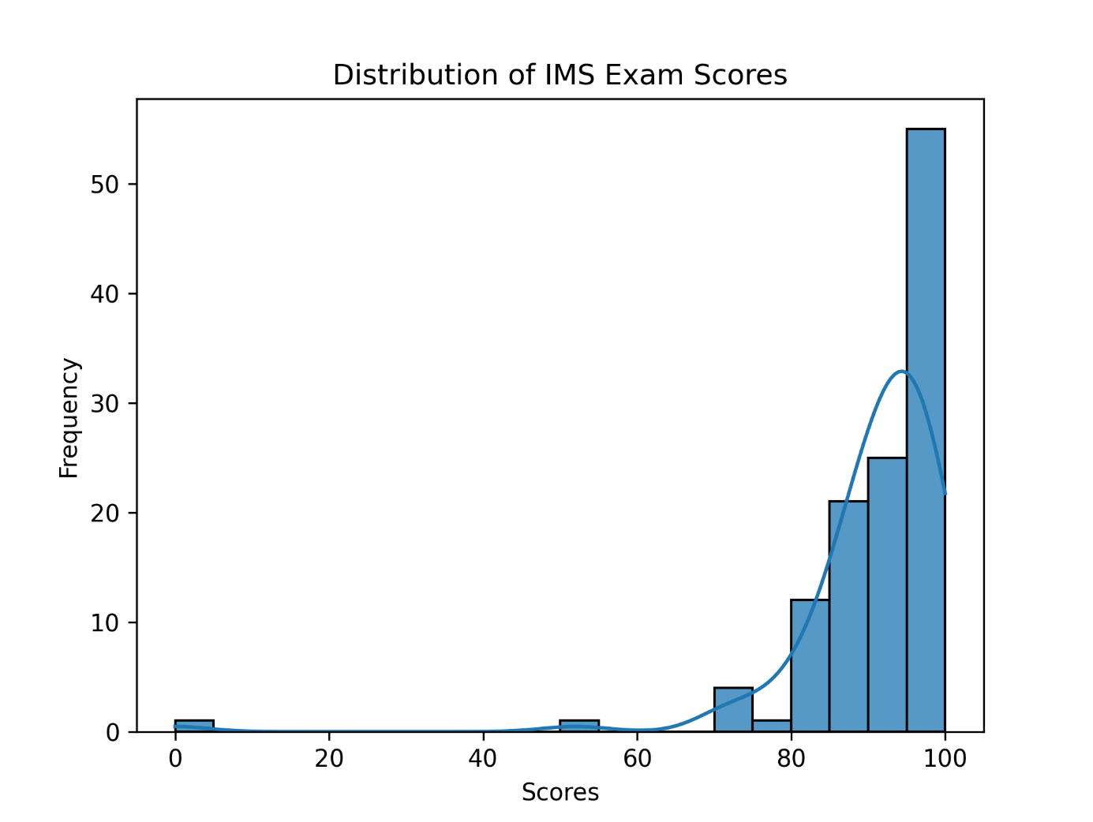

The scores for the IMS group are heavily skewed towards the higher end, with a peak at the 100-score mark. This indicates that a significant number of IMS students scored perfectly or near-perfectly on the exam.

There are very few low scores, suggesting that the IMS group generally found the exam to be within their capabilities, or that they were well-prepared.

### US Exam Scores Distribution:

The U.S. students' scores are more evenly spread out, with a slight skew towards the higher end. The peak frequency is around the 90-95 score range. There is a broader range of scores among U.S. students, indicating more variability in performance compared to the IMS group.

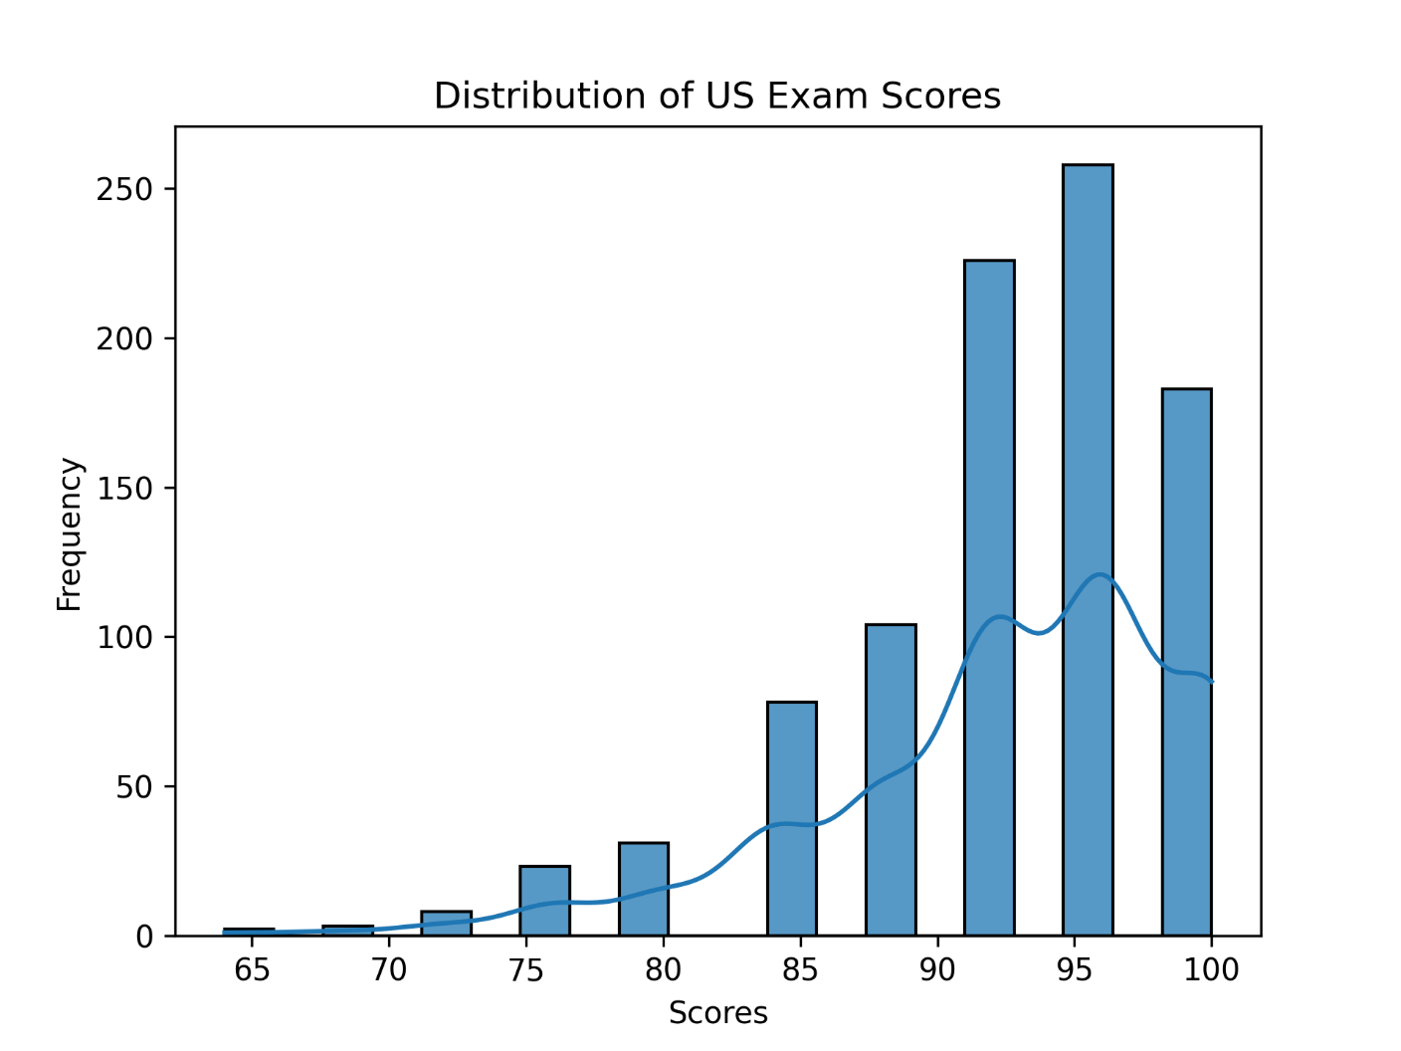

### Total Exam Scores Distribution:

When both groups are combined, the distribution has two peaks (bimodal), one around the 85-score range and a sharper peak at 100. This bimodality could suggest that one group performed distinctly differently from the other, which is supported by the individual histograms.

### Recommendations:

Review Exam Difficulty: Given the high scores, especially among IMS students, review the exam's difficulty level to ensure its adequately testing the desired knowledge and comprehension levels.

Investigate Preparation Levels: The differences in score distributions suggest that there may be differences in preparation levels or prior knowledge between the two groups. Investigate the study resources and support systems available to each group.

Curriculum and Instruction Assessment: If the exam is intended to be challenging, consider whether the curriculum and instruction are aligning well with the assessment, especially for the U.S. students whose scores show greater variability.

Consider Exam Conditions: Since the exam was open note and open book, consider if time constraints or the nature of the exam (e.g., application vs. recall questions) are influencing the results.

Evaluate Scoring Consistency: Ensure that the scoring of the exam is consistent and that there are no biases affecting the results.

Further Analysis: If available, further analysis could be done using item response theory to evaluate the difficulty of individual questions and the exam's ability to discriminate between different levels of student ability.

Tailor Support: For students who scored lower, consider additional support or review sessions to address gaps in knowledge.

Cultural or Educational Background Considerations: If IMS students are coming from different educational backgrounds, their approach to open-note exams might be different from that of U.S. students, potentially explaining the score distribution.

Investigate Outliers: For any outliers, especially in the U.S. group, investigate if there were any external factors affecting those students' performance.

Feedback Mechanisms: Implement feedback mechanisms for students to share their experiences of the exam to gain insights into how they prepared and their thoughts on the exam difficulty.

By examining not just the overall scores but also the distribution and the conditions of the exam, you can gain a better understanding of both groups' performance and make informed decisions to enhance the learning and assessment process.

## Distribution of CTGL scores. Here's an analysis of the histogram:

(Contribution to Group Learning)

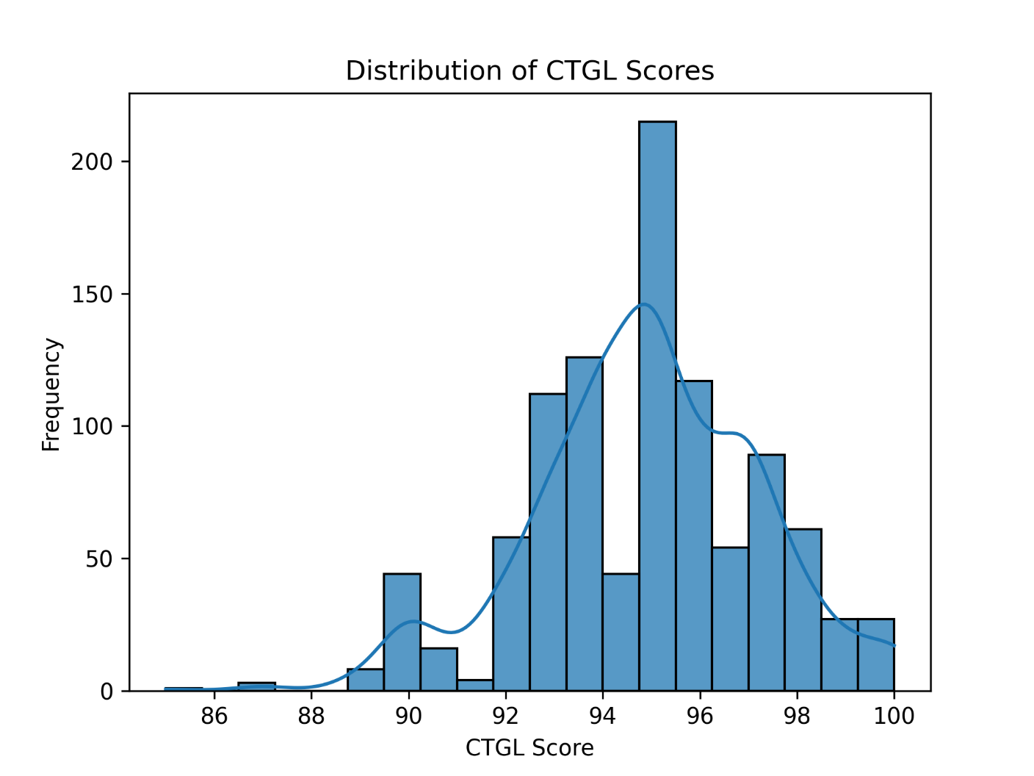

Central Tendency: The distribution has a clear mode around the score of 96, which is the most frequent score range. There seems to be a slight left skew to the distribution, with more scores concentrated on the higher end towards 100.

Spread: The scores range from the mid-80s to a perfect score of 100, with the majority of scores falling between 94 and 98. The spread of the distribution indicates some variability in scores but with a tendency towards higher performance.

Shape: The histogram is not perfectly symmetrical and shows a slight skew to the left, indicating that fewer students received lower scores. The tail on the left side (lower scores) is longer than the right side (higher scores), which also indicates a negative skew.

Peaks: The distribution is unimodal with one clear peak, suggesting that scores tend to cluster around this modal range. There is a small rise again near the perfect score of 100, which could indicate a secondary cluster of high achievers.

Outliers: There are no extreme outliers on the higher end, but the lower frequency of scores on the left might be considered mild outliers.

Implications: The concentration of scores at the high end suggests that the assessment may not be challenging enough, as a significant number of students are scoring in the upper ranges. If the assessment's purpose is to differentiate among students' levels of mastery, the current distribution suggests that it may not be fully effective in that regard.

### Recommendations:

Review Assessment Content: Consider whether the assessment is challenging enough or if it aligns well with the intended learning outcomes.

Differentiation: If there is a need to differentiate more effectively between varying levels of student performance, consider revising the exam to include more challenging or diverse question types.

Instructional Review: Investigate if the instruction prior to the exam has been particularly effective, leading to high scores, or if the exam format (such as open book/note) allows for higher performance.

Further Analysis: Conduct a more detailed item analysis to see if certain questions were too easy or not discriminating enough between different levels of student understanding.

Curriculum Alignment: Ensure that the curriculum is rigorous, and that the assessment is a true reflection of students' understanding and not just their test-taking abilities.

Overall, the distribution suggests that most students performed well on this CTGL assessment, with a tendency towards higher scores. This can be a positive indication of students' understanding and preparation, but it might also signal a need to adjust the assessment's difficulty to ensure it's challenging and discriminating effectively across the spectrum of student ability.

## CTGL further inputs and analysis

The term "Contribution to Group Learning," often associated with participation grades, is a subjective measure used in educational settings to assess the extent and quality of a student's engagement in the learning process, particularly within group activities or discussions. Here's an analysis of how a standardized rubric can support the assessment of "Contribution to Group Learning" (CTGL) and its implications:

Objective Criteria: A standardized rubric can provide objective criteria for what constitutes effective participation. This can range from the frequency of contributions to the relevance and constructiveness of a student's input. It mitigates the subjectivity often associated with participation grades.

Equity in Assessment: Without a standardized rubric, participation grades can be susceptible to bias, whether intentional or unconscious. A rubric ensures that all students are aware of how their participation is being evaluated and what is expected of them.

Enhanced Feedback: By defining specific levels of performance, a rubric can help educators provide more detailed and actionable feedback to students. Instead of a generic "good participation" comment, instructors can point to specific behaviors and contributions that were either exemplary or in need of improvement.

Self-Assessment and Reflection: Rubrics can be shared with students, allowing them to self-assess and reflect on their own contributions to group learning. This can encourage students to take a more active role in their learning process.

Consistency Across Teams: In group projects, a standardized rubric ensures that all teams are evaluated on the same criteria, which is particularly important if the CTGL score is used to bolster other assessments. It helps maintain a standard of fairness across different groups.

Performance Improvement: With clear expectations outlined, students may be more motivated to engage in the learning process, which can lead to overall improvement in class dynamics and learning outcomes.

Documentation for Grade Disputes: Should a student question their participation grade, the rubric provides a documented rationale for the grade they received, which can be useful in resolving disputes.

Supporting Lower Performances: In cases where a student's performance on other assessments is lower than expected, a well-defined CTGL can serve to recognize the student's other valuable contributions to the learning environment. However, it should be applied consistently to avoid inflation of grades without merit.

In the context of the histograms, if CTGL scores are being used to supplement assessment grades, a standardized rubric becomes essential to ensure that this contribution is measured fairly and consistently. If CTGL scores are not currently based on a standardized rubric, the histograms might reflect inconsistencies in grading participation across different groups or instructors. Implementing a rubric could help normalize this distribution, making the CTGL scores a more reliable indicator of student engagement.

## CTGL and Wt_total

### Scatter plot 1

Here's an analysis of the scatter plot:

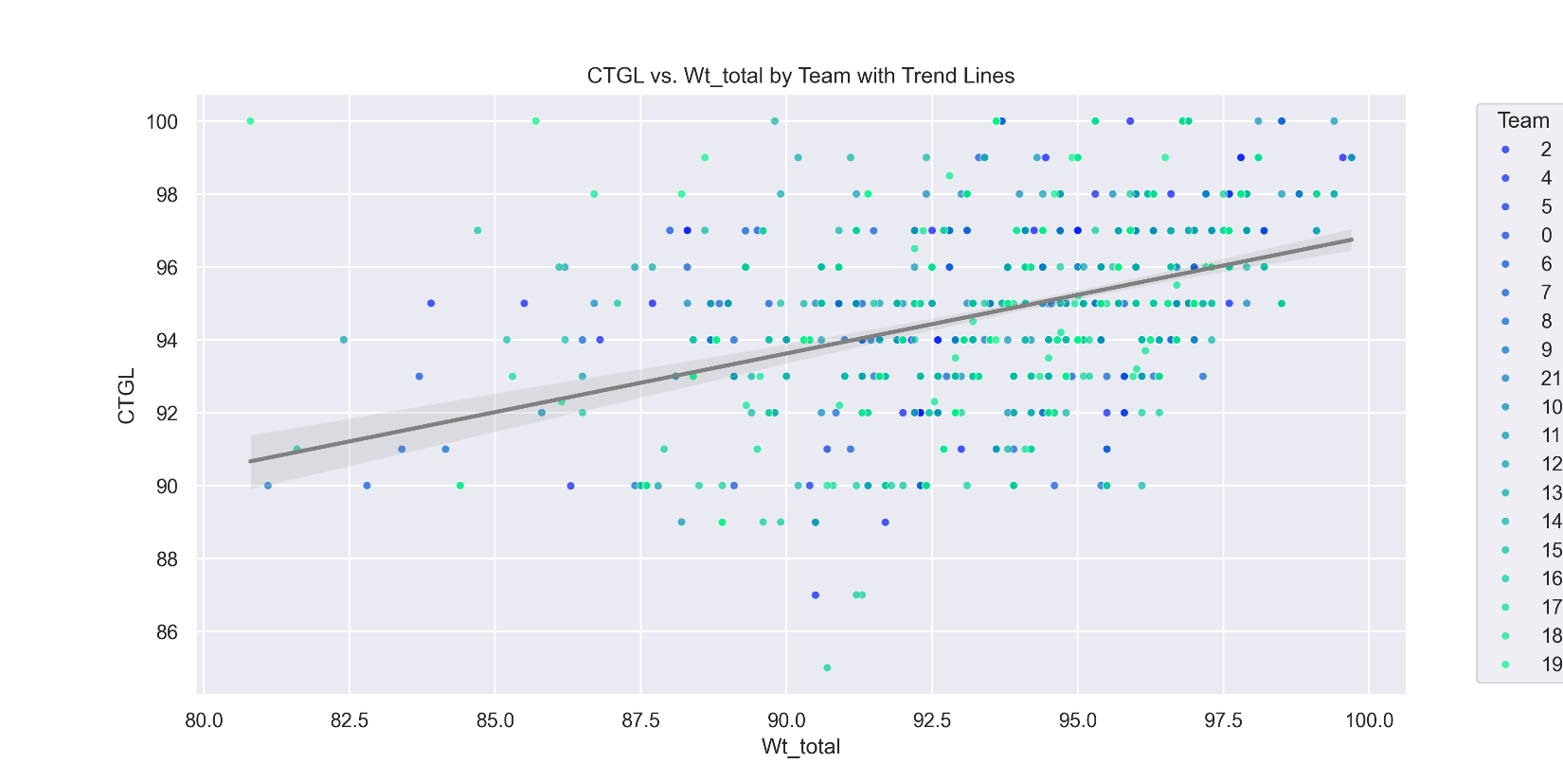

CTGL vs. Wt_total Relationship: The plot shows a positive correlation between CTGL and Wt_total, as evidenced by the upward trend of the data points. This means that higher values of Wt_total are associated with higher values of CTGL.

Trend Line: A trend line (a linear regression line) is included in the plot, which models the relationship between CTGL and Wt_total. The shaded area around the trend line represents the confidence interval for this prediction, suggesting where future data points are expected to fall, given the current data.

Team Distribution: The different colors represent different teams. The distribution of colors shows how the teams are spread across the range of Wt_total and CTGL values. Some teams may have a wider spread of scores, indicating more variability within those teams.

Data Clustering: There appears to be clustering of data points around certain values of Wt_total, which might indicate common scoring benchmarks or grading standards.

Outliers: If any data points are significantly far from the trend line or other points, they would be considered outliers. Outliers can indicate special cases or errors in the data.

Inter-Team Comparison: It can be observed whether some teams consistently score higher or lower on both metrics, or if there is a lot of overlap between teams.

Scale and Axes: The x-axis represents Wt_total with values ranging from 80 to 100, while the y-axis represents CTGL with values from the high 80s to 100. The axes' scales allow for a detailed view of the data's distribution.

This type of visualization is useful for understanding the relationship between two continuous variables and how they might be affected by a categorical group variable. It can also help identify trends, patterns, or anomalies in the data across different subgroups.

### Scatterplot 2: The relationship between CTGL and Wt_total

Clustering by Team: The data points are color-coded by team, which allows for an easy visual comparison of where each team's members fall on the CTGL vs. Wt_total spectrum. Some teams may cluster tightly together, suggesting consistency within those teams in terms of their CTGL and Wt_total scores. Other teams may have a broader distribution, which could indicate more variability in performance within those teams.

Range of Scores: The plot shows the range of scores for each team across the Wt_total and CTGL metrics. This can help identify if certain teams score higher or lower than others.

Correlation: While the previous image included a trend line, this plot does not seem to have one. However, it still provides a visual representation of the relationship between the two variables. If the points for each team tend to move upwards to the right, this suggests a positive correlation.

Outliers: Any points that fall far from the main cluster of their respective team color could be considered outliers. These may be points of interest for further investigation.

Visual Clarity: Without a trend line, this scatter plot gives a clean look at the raw data distributions, which can be useful for seeing the natural groupings and spread without the influence of a fitted model.

Comparison with Previous Images: Compared to the previous images, this scatter plot allows us to look at the team-specific distributions without superimposed trend lines, which could give a clearer picture of each team's performance distribution.

In summary, this scatter plot continues to add depth to the analysis by showing the individual data points for each team, which can help identify patterns, consistency within teams, and outliers that may warrant further investigation.

## Boxplot: boxplot representing the distribution of CTGL across the Teams

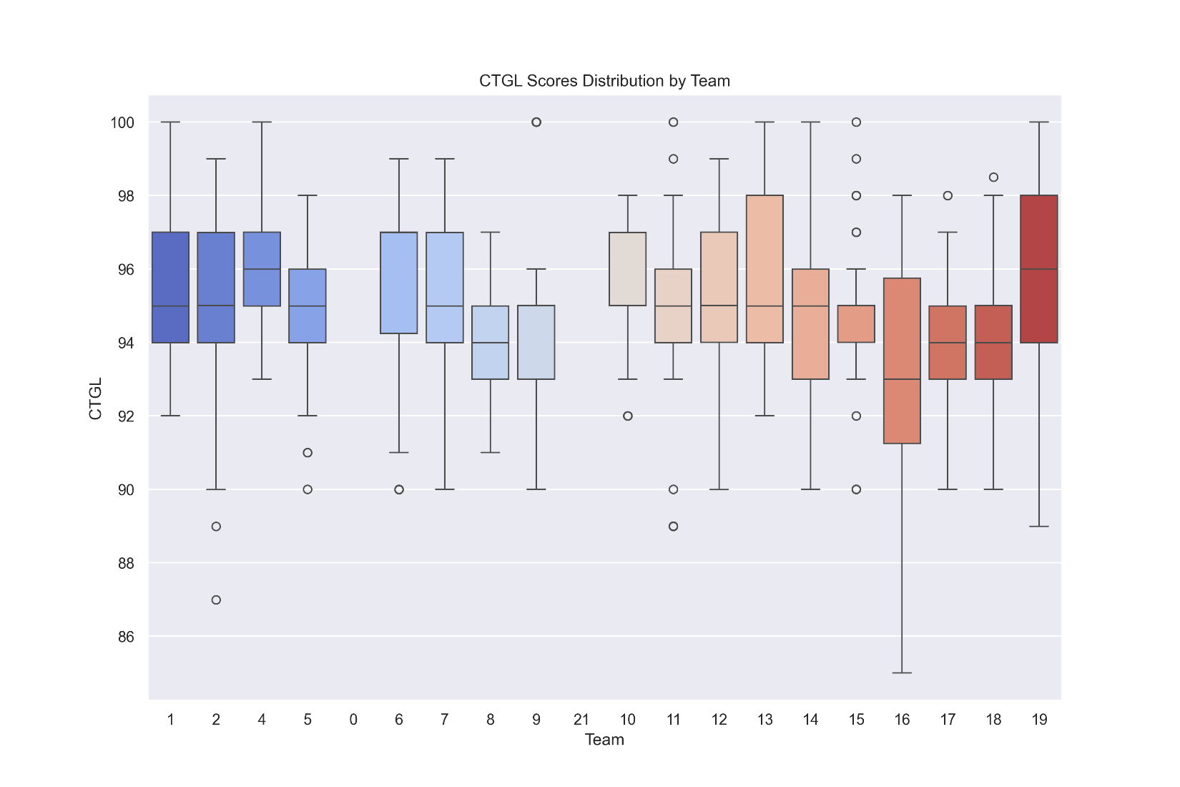Across different teams, labeled 1 through 19. Here’s what the boxplot tells us:

Central Tendency and Spread: Each box represent the interquartile range (IQR) of the scores for a team, which is the range between the 25th percentile (Q1) and the 75th percentile (Q3). The line inside the box shows the median score for each team. Teams with taller boxes have a greater spread in scores, indicating more variability among the team members' CTGL scores.

Outliers: The points outside the 'whiskers' (the lines extending from the top and bottom of each box) represent outliers, which are scores that fall significantly higher or lower than the rest of the data. Some teams, like Team 0 and Team 6, have outliers below the lower whisker, indicating a few team members with unusually low scores.

Comparison Across Teams: Teams are colored differently, to distinguish between different groups or to enhance visual separation. Teams with higher median scores (line inside the box) have higher performance on the CTGL metric. Some teams have very compact distributions, indicating consistent performance among team members, while others show more diversity in scores.

Whiskers: The whiskers extend to the furthest points within 1.5 times the IQR from the quartiles, except for outliers. Teams with longer whiskers indicate a wider range of scores within the central 50% of the data.

Symmetry: Some boxes are symmetric around the median, suggesting a more even distribution of scores. Asymmetric boxes, where one half of the box is longer than the other, indicate a skew in the data; for example, if the top half of the box is longer, it means more scores are distributed towards the higher end.

This type of visualization is helpful for quickly comparing the central tendency and variability of scores across multiple groups, identifying outliers, and assessing the overall distribution of scores. It provides a clear visual comparison of how different teams perform in terms of CTGL scores and can highlight teams that may require additional attention or investigation due to their variability or the presence of outliers.

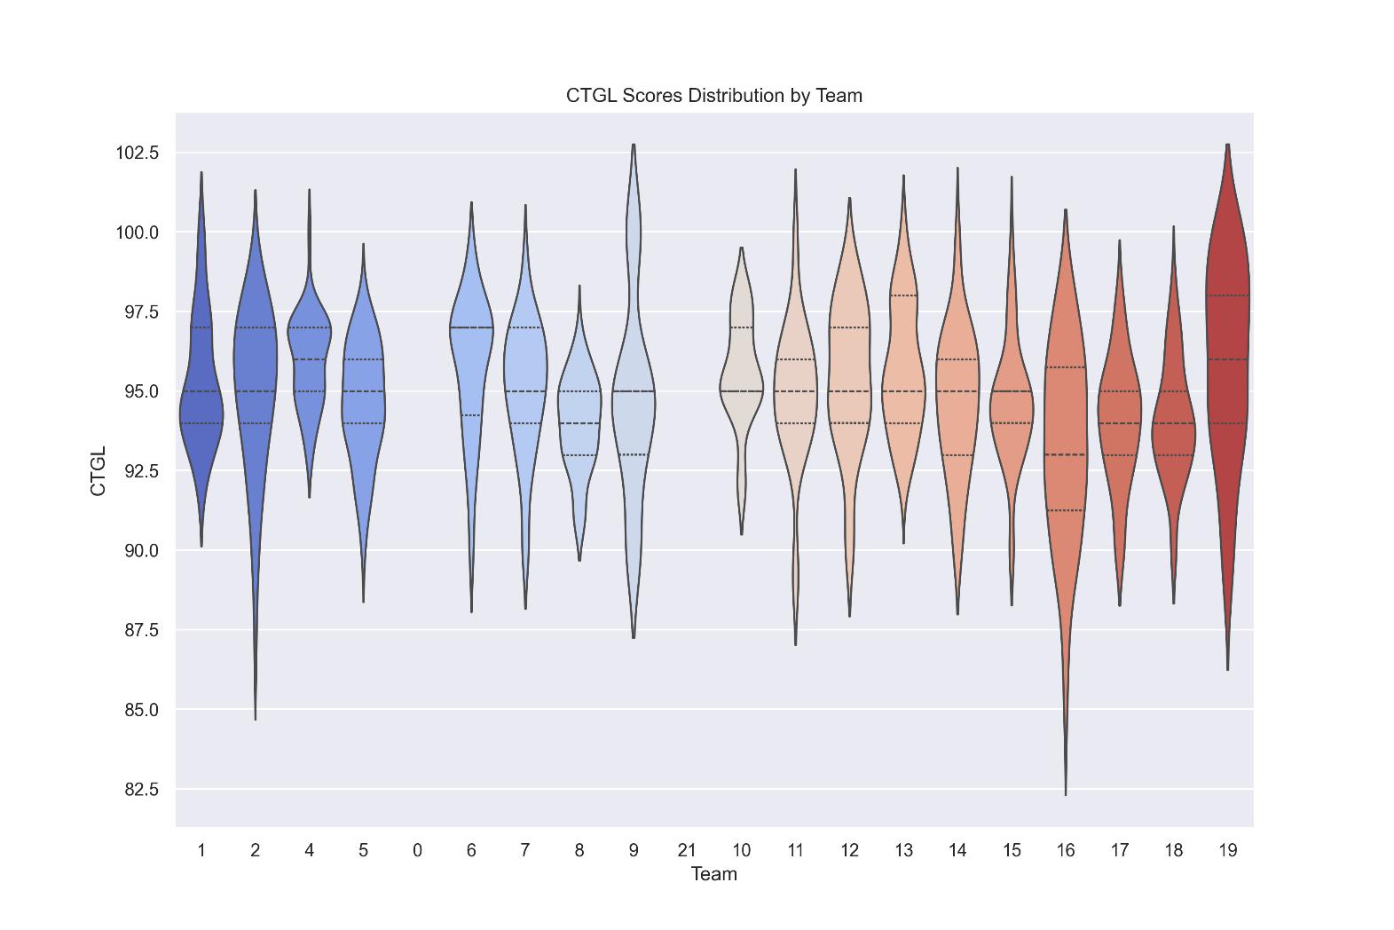

## Violin plots: Representing the distribution of CTGL across the Teams

Representing the distribution of CTGL scores across different teams, labeled from 1 to 19 (with some numbers missing, possibly indicating that there is no data for those teams, or they have been excluded for some reason).

Here's what we can infer from this plot:

Score Distribution: The violin plots show the distribution of CTGL scores within each team. The width of the plot at different score levels indicates the density of data points, with wider sections meaning more data points at that score level.

Median Scores: The white dot in the center of each violin plot likely represents the median score for that team. The median is the value separating the higher half from the lower half of the data.

Interquartile Range: The thick black bar within the violin plot indicates the interquartile range (IQR), which is the range between the first quartile (25th percentile) and the third quartile (75th percentile). This shows where the middle 50% of scores lie.

Score Range: The thin line extending from the IQR shows the range of the data, excluding outliers. It indicates the spread of scores from the lowest to the highest within each team.

Comparing Teams: Teams with narrower violins have less variability in their scores, while wider violins indicate more variability. Some teams have a larger range of scores (longer thin lines), while others are more compact, suggesting consistency in scores.

Outliers: If there are any points outside the thin lines, those would be considered outliers, but they are not visible in this plot.

Symmetry and Skewness: The symmetry of the violin plot around the median can indicate the skewness of the distribution. A symmetrical violin suggests an even distribution of scores above and below the median. If one side of the violin is longer or fatter, this indicates skewness in the scores towards higher or lower values.

Team Performance: Teams towards the right (with higher team numbers) seem to have higher medians and less variability, suggesting potentially better performance or grading standards. Teams on the left have lower median scores and more variability, which could indicate more diverse performance within the team or different scoring standards.

This plot is useful for comparing the performance of different teams, understanding the distribution of scores within each team, and quickly identifying any teams with particularly high or low scores, or with unusual distributions such as a single team with a bimodal distribution. It can help in identifying teams that may need additional support or recognition.

## Correlation heatmap of assessments.

Here's an analysis of the heatmap:

Color Scheme: The heatmap uses a color gradient from blue to red to represent correlation values between -1.0 and 1.0. Blue indicates a negative correlation, red indicates a positive correlation, and white or pale colors indicate a low or no correlation.

Correlations:

High Positive Correlations:

- Wt_total and BB_exam_us have a perfect correlation of 1.00, which suggests they are effectively measuring the same thing or are directly related to each other.

- Wt_total also has a very high correlation (0.91) with Combined_Scores, indicating a strong relationship.

- BB_exam_us and Combined_Scores also show a perfect correlation, implying that the combined score is heavily influenced by the BB_exam_us score.

Moderate Positive Correlations:

- CTGL has moderate correlations with Wt_total (0.42), Total_pts (0.50), and BB_exam_ims (0.54), suggesting some level of relationship.

- Wt_total and Total_pts are moderately correlated (0.46), suggesting they share some common factors but also have distinct components.

- BB_exam_ims has a moderate correlation with Combined_Scores (0.63), indicating it is a component of the combined score but not as strongly weighted as BB_exam_us.

Low or No Correlation:

- CTGL has a very low correlation with BB_exam_us (0.06) and Combined_Scores (0.06), suggesting that whatever CTGL is measuring, it is largely independent of these particular exam scores.

- BB_exam_ims and Total_pts have a low correlation (0.22), which suggests they measure different aspects or outcomes.

- BB_exam_ims has a slightly negative correlation with BB_exam_us (-0.09), which is unexpected given they are both exam scores; this could indicate they are designed to measure completely different competencies.

Diagonal: The diagonal from the top left to the bottom right shows perfect correlations (1.00) as it is correlating each variable with itself.

This heatmap is useful for understanding the relationships between different assessment metrics. If this is from an educational setting, such data could help educators understand how different assessments contribute to overall scores and identify if any assessments are redundant. The strong correlations between some of the variables suggest that some of the metrics may be redundant. For instance, since Wt_total, BB_exam_us, and Combined_Scores are all perfectly or almost perfectly correlated, they might be representing the same underlying performance metric.

## Facet grid of scatter plots- relationship between two variables: CTGL and Wt_total, for different teams

(labeled team 0 to team 21, with some numbers missing which could be due to the absence of those teams or a result of the image cropping).

A facet grid is a collection of similar plots separated into panels based on the levels of one or more categorical variables—in this case, the "team" variable. Here's what the plot tells us:

CTGL vs. Wt_total Relationship:

- Each panel shows a scatter plot for a different team. The plots show a positive relationship between CTGL and Wt_total, which means that as Wt_total increases, CTGL also tends to increase.

Variability Between Teams: Some teams show a very tight clustering of points, indicating a strong and consistent relationship between CTGL and Wt_total within those teams. Other teams have points that are more spread out, suggesting more variability in the relationship between these two variables within those teams.

Team Performance: The range of values for both CTGL and Wt_total varies between teams. Some teams have points that span a wide range of the x-axis (Wt_total), others span a wide range of the y-axis (CTGL), and some are tightly clustered in both. This could indicate differences in team performance or in how the teams are being assessed.

Outliers: Certain teams have outliers—points that do not follow the general trend of the rest of the data. These could be cases of exceptional performance or data entry errors.

Consistency Across Teams: There are differences in how clustered or spread out the points are across different teams. This could reflect differences in the homogeneity of performance within teams.

Scale and Axes: The axes are consistent across all plots, which allows for direct comparison between the teams. The x-axis (Wt_total) ranges from around 80 to 100, and the y-axis (CTGL) ranges from around 85 to 100.

Data Distribution: The distribution of data points in each facet can give insight into the spread and central tendency of scores for each team.

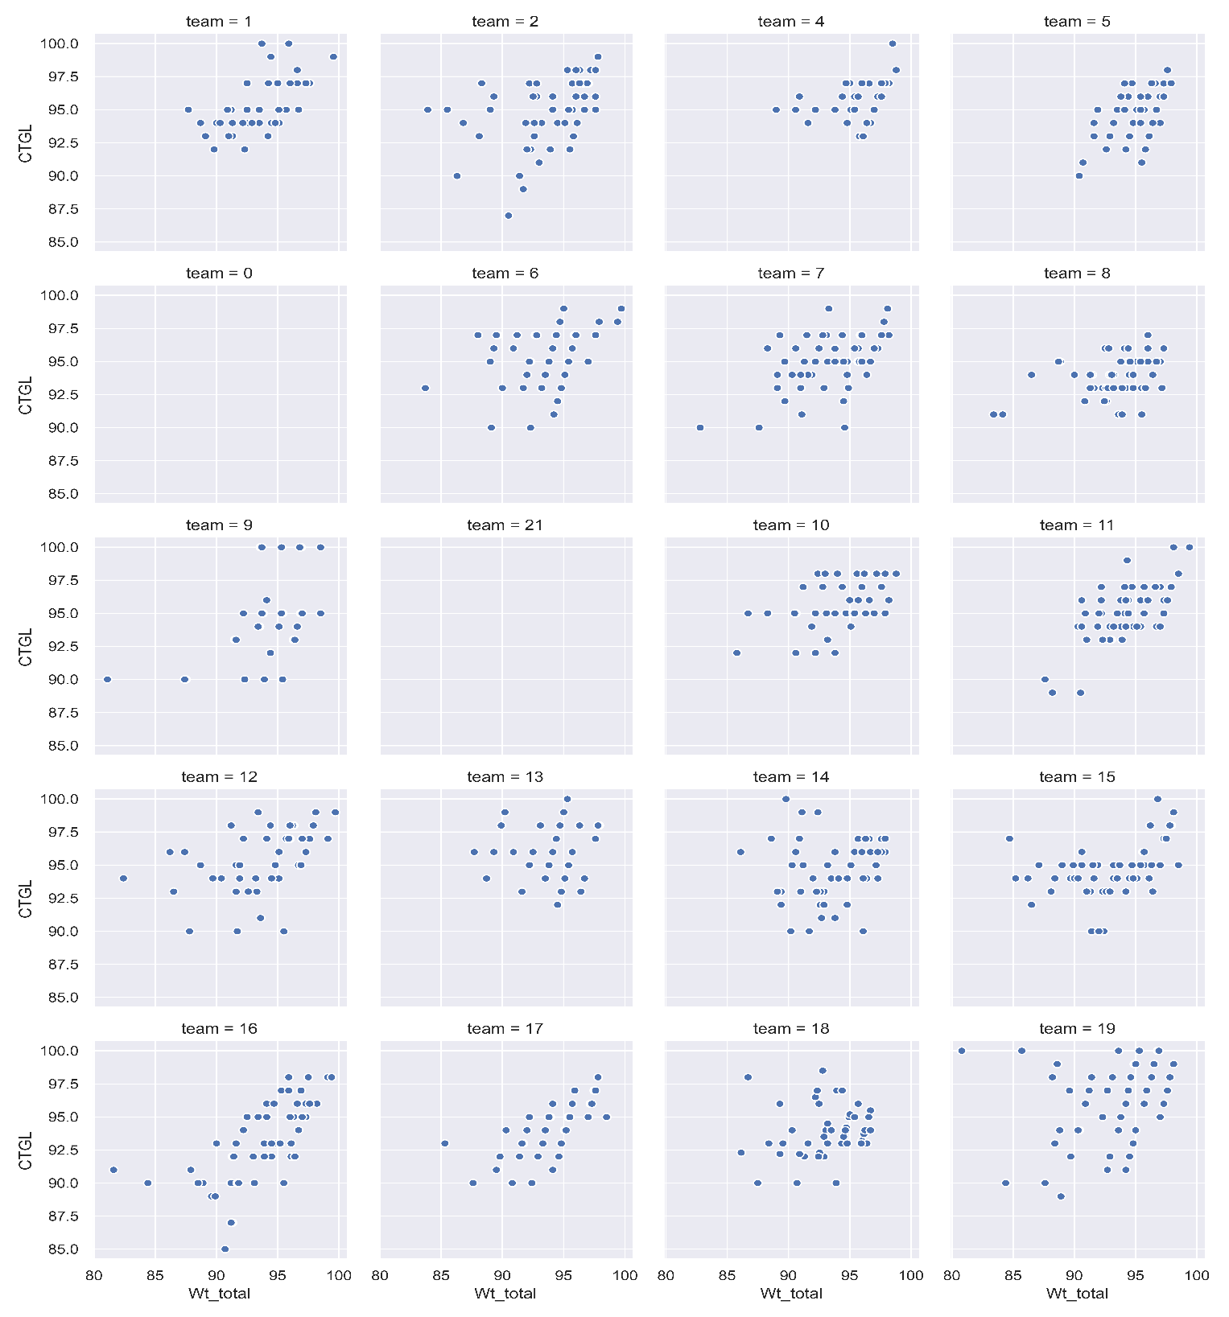This kind of visualization is particularly useful for comparing subgroups within a dataset and for identifying whether certain patterns hold consistently across those subgroups. In this case, it helps in assessing whether the positive relationship between CTGL and Wt_total is a general pattern or if it varies significantly from team to team.

## Pair plot (also known as a scatterplot matrix)

Displays the pairwise relationships between different variables in a dataset. Each scatterplot shows the relationship between two variables, with points colored by a categorical variable, which in this case appears to be "team" with values from 1 to 19. Along the diagonal are density plots for each variable, showing the distribution of values.

Variables: The variables plotted are the same as those in the heatmap: CTGL, Wt_total, Total_pts, BB_exam_us, BB_exam_ims, and Combined_Scores.

Pairwise Relationships:

- Positive Linear Relationships: Several pairs of variables show a positive linear relationship, indicated by points forming an upward trend from left to right. This suggests that as one variable increases, the other tends to increase as well.

- Clusters: Some plots show clustering of points, which may indicate subgroups within the data that share similar characteristics, related to the "team" color coding.

Here's an analysis of the pair plot:

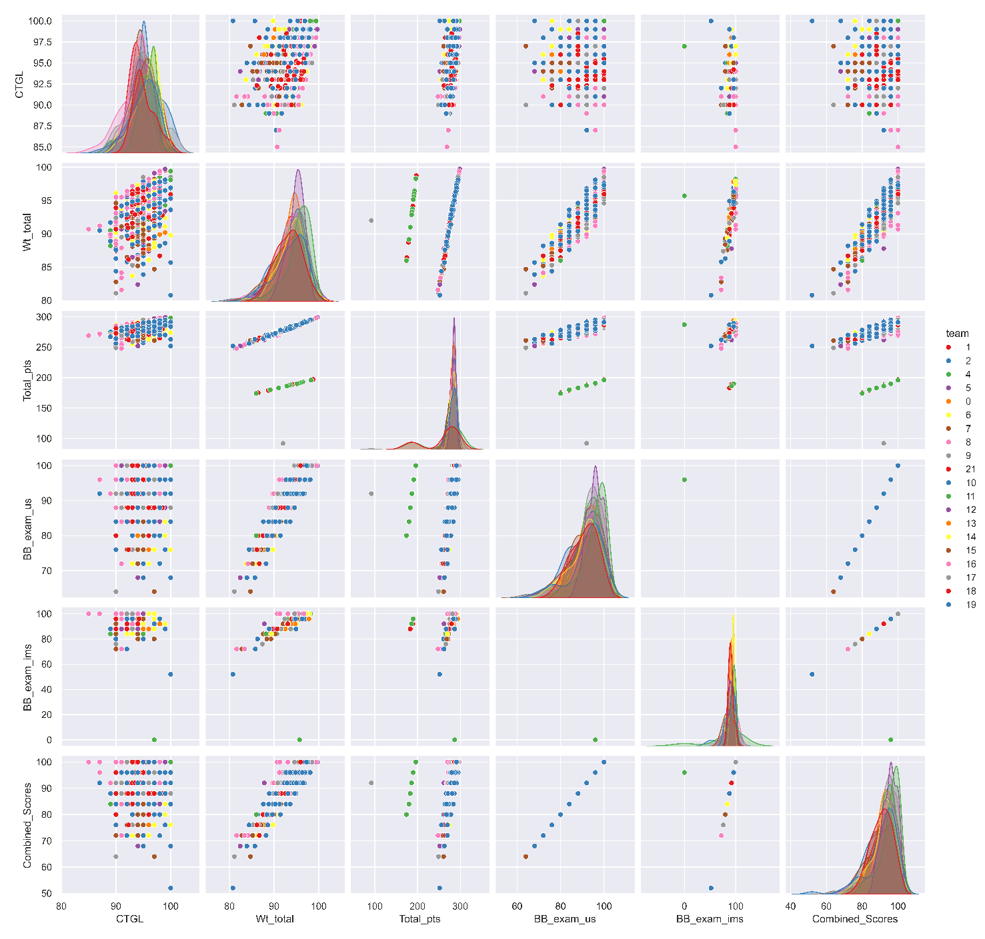Distributions (Diagonal Density Plots): Each density plot on the diagonal shows how the values of a single variable are distributed. Some variables show a single, clear peak, while others have multiple peaks or a wider spread, indicating variability in scores among the teams.

Color Coding by "Team": The color coding provides additional context, potentially representing different groups within the dataset. The spread of colors across the scatterplots indicates how the different teams are distributed with respect to each pair of variables.

Outliers: In some scatterplots, there may be points that are far away from the main cluster, which could be outliers. These are worth investigating as they might represent special cases or errors in the data.

Trends by Team: The distribution of colors may show if certain teams tend to score higher or lower on certain metrics, or if there's a lot of variability within teams.

This type of visualization is useful for identifying trends, relationships, and potential outliers in the data, as well as for generating hypotheses about the factors that could influence these variables. For instance, if certain teams consistently score higher on certain assessments, there might be underlying factors contributing to their performance. It can also reveal if some variables are redundant, as seen in the correlation heatmap, by showing how closely the points follow a straight line.